# Gurukula-The Teacher´s House

Educating in value s to be peaceful

HpS/asa  – AgtSP… better would be enthusiastic (utsahan (noi 3)) in a…, no?

in a changing world

Current Education System

* Obsolete and inefficient

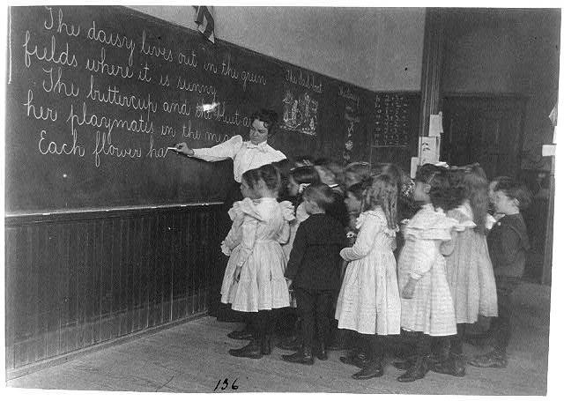

* Focused on information
* Oriented to obtain a social position

* Same for different students
* Experienced in homogeneous groups
* Does not resolve emotional conflicts

# Results of this Education

* Among the top 12 economies in the world are: arms sales market, pornography, drug dealing, human trafficking, pharma.
* 800,000 people commit suicide each year
* 40 armed conflicts on the planet that caused

4,150,000 deaths

* 137 women murdered per day in the world.
* Pollution of the planet
* Sistemic violence in many places

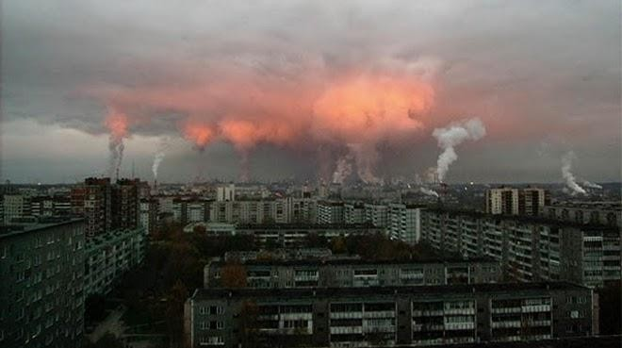

# Gurukula Proposes

* Innovative and efficient education
* Focused on values. Ego, Resilience, Empathy
* Oriented to train upright people
* Differentiated according to the different natures and circumstances of the student.
* Universal accessibility, heterogeneous groups.
* Ability to resolve personal conflicts.
* Extracurricular, outside the educational bureaucracy.

HpS/asa  – What about Serious Consideration of Mono Theism? (In Spain they say that Hanuman is the greatest mono theist).

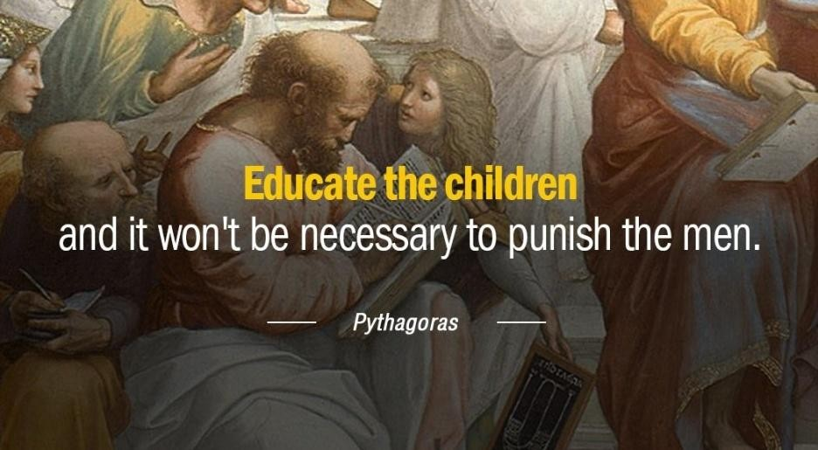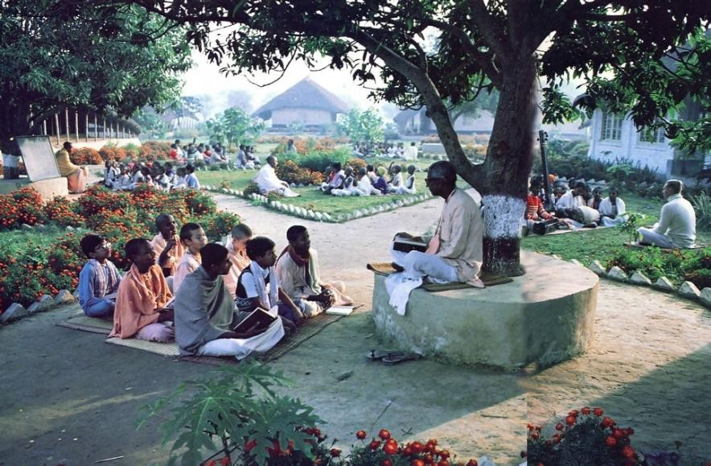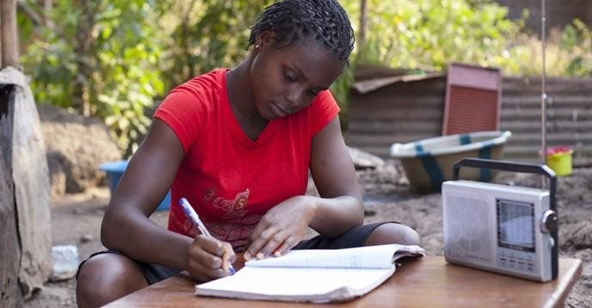

# Gurukula

* A **single** teacher for **four years. Hundreds** of

remote expert tutors (own content, Khan Academy, udacity,

Edx, Ck-12, Free code camp, Smarthistory, Saylor Academy,

PeertoPeerUniversity, Creative Commons, Iste, Masterclass, Babbel, Chineasy, Lambda school, , University of the people, Platzi, Coursera, etc.)

* While **parents** are working, with **little time** and emotionally **attached**:
* The **teacher** creates a **loving bond** without attachment and can exercise **discipline**.
* The **teacher supports** the lessons of the remote expert **tutors**.
* 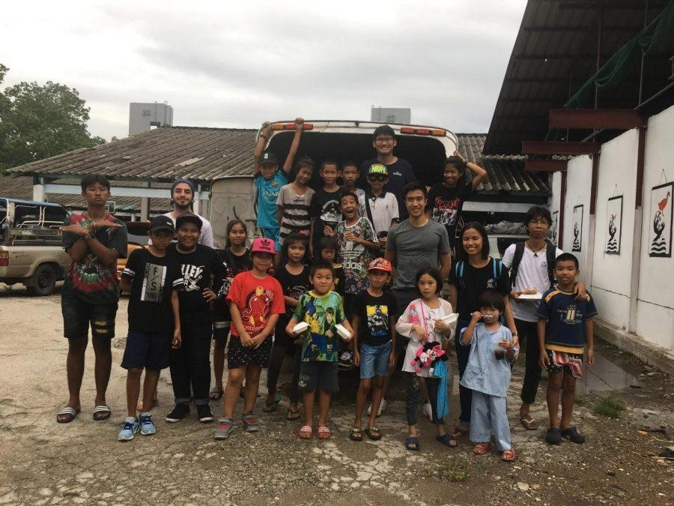Focused on Forming the character of the student:
  + Respect for authority
  + Service attitude
  + Sense of responsibility
  + Solidarity
* Ego dilution, Resilience and Empathy.
* HpS/asa  – Ego purification.
* **Four years of common cycle: 10 to 13 years, a single teacher.**
* 1) Health (nutrition and body care)
* 2) Cooking and hygiene (practical application of health management)
* 3) Physical activity (yoga, kung fu, chi kung, karate, etc.)
* 4) Languages (Spanish, English, Chinese, Sanskrit, French, Russian, etc.).
* 5) Agriculture, Permaculture
* 6) Computer programming and finance
* 7) Music (composition and instruments) and Arts
* 8) Philosophy (worldview and paradigms). We want to teach until the level of Paramatma. Discuss different dharmas. Then each student decides his/her spiritual journey.

HpS/asa  – This is precisely the model we have learned from Srila Prabhupada for preaching, teaching in the modern university, secular education atmosphere.

1. What is matter? Science idea, ayurveda, vastu veda, bhumir apo nalo vayu (BG 7.4)
2. 2. What is “atma”. Matter is insufficient to describe life. Eddington, Quantum Questions. Free will.
3. 3.What are two divisions of atma --- jiva atma and param atma.. put this in their panguage.
4. 4. Bhagavan. We do not deal with this in the secular curriculum. We can encourage the investigation but at point 4 it becomes a personal thing and the student can discuss it with the teacher particularly or they can find it in their own religion. Support the effort in different religions based upon good 1,2 ,3.

* **Specialty** according to **nature** of the student: 14 to 17 years (consider gender separation), a single teacher
* 1) **Intellectual**: Philosophy, medicine and psychology
* 2) **Leadership**: Political Science, Military Art and Martial Arts.
* 3) **Business**: Economy and finance
* 4) **Manual skill**: Trades (music, construction, horticulture, carpentry, etc.)
* **Universal accessibility:** Enrollment between 5 and 7% of family income (an algorithm will be created). Families will contribute money and/ or time.
* **Heterogeneous groups.** Different realities and contexts.
* **Extracurricular,** independence from the educational bureaucracy.

# Gurukula: Functioning

* **A centralized Support Center:**
* Generates the methodology and pedagogical content
* Generates the necessary technology and interconnectivity for remote classes (online)
* Establishes communication, marketing and institutional relationships
* Manage Finance, Accounting and legal
* HpS/asa  Willim Bellah = School is like a three legged stool. Stand on Institutinal/Community, Teachers and Parents. We might add, Students. They have free will. They gotta wanta learn character values.

Above seems to emphasize the Institution. A real teacher must teach. They will sit down beside the road and open a school for teaching Vedic knowledge.

# Gurukula: Functioning

* **An Application center** (Gurukula, The Master's house):
* One teacher for every 21 students
* HpS/asa  –

Too high!

* Study 16 hours a week, 4 hours a day, Monday, Tuesday, Thursday and Friday. Extracurricular activities one weekend a month.
* A cleaning and maintenance person
* A secretary
* Any real-life setting can be a Classroom (in the Gurukula, hospital, nature, senior center, sports field, supermarket, etc.)

Why now?

* An increasing percentage of the population is seeking a **paradigm shift**. This includes how we educate our youth.

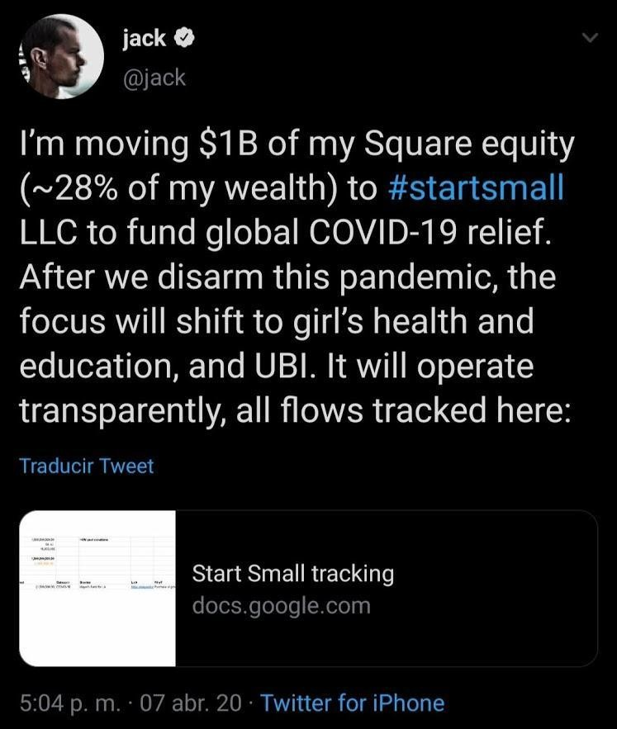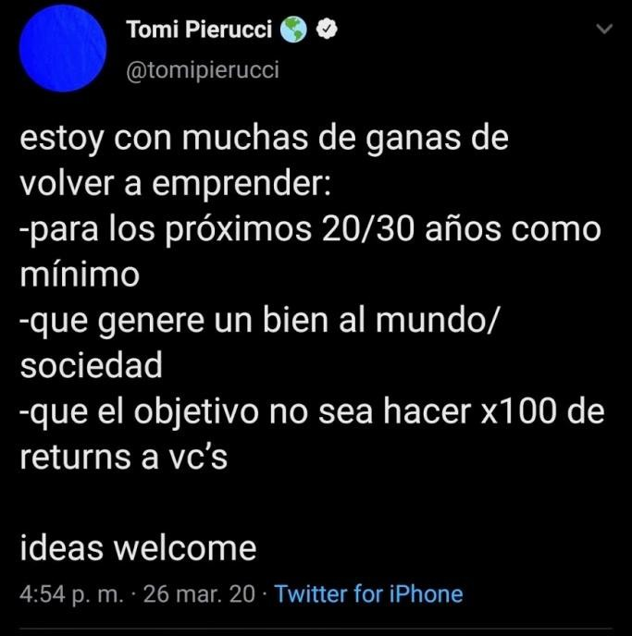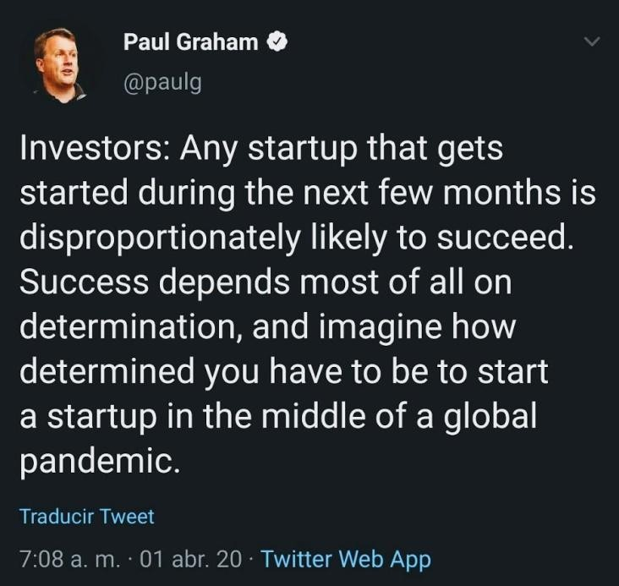

* The **entrepreneurial ecosystem** wants to **invest** in education projects. There are several accelerators and VCs interested in **Edtech**.

# Target market

-People who want to promote and provide children with an education based on principles and competencies.

-Those adults who consider the current educational system obsolete and ineffective.

-Institutions that want to innovate in education.

# Income

* School fees (between 5 and 7% of family income per student, algorithm)
* State subsidies
* Donations from individuals

Not scalable

Scalable

Knowledge

focused

Focused on Values

Traditional Education

-

Montessori Education

-

Waldorf pedagogy

-

Asiri method

*-*

Vittra Utbildning

-

Khan Academy

-

University of the People

-

Lambda School

Gurukula: The teacher´s house

## Development: Roadmap

**1. Team Building:** We will start with one person per department

### Human resources and pedagogy: 3 people

Mission: Develop the pedagogical methodology, facilitate its implementation, train the Human Resource. Develop and select curricular content.

### Technology and interconnectivity: 3 people

Mission: To generate the technological substrate that will allow the Gurukula concept and curricular content to be disseminated and scaled globally. Allow interconnectivity of centers globally.

### Finance, Accounting and Legal: 3 people

Mission: Manage the flow of money, collections, donations, subsidies, payments, investments, insurance, permits, ratings and legal conflicts.

### Communication, marketing, institutional relations: 3 people

Mission: To publicize, spread and retain the Gurukula concept. Generate agreements and alliances with other institutions.

**In each School** (When it opens**)**: **1 cleaning and maintenance person, 1 secretary person, 1 Teacher every 25 students.**

# Development: Roadmap

1. Opening of the first headquarters. (1 to 4 cohorts)
2. Opening of following venues.
3. Climb nationally and internationally.
4. Strengthen the international community.
5. Network of graduates and families.

Contact

* nikasio@gmail.com
* +5492235806110

HpS/asa  –

Moving too quickly to step three of project development.  
1. Who am I? What are your passions and duties? Must keep rethinking this again and again and again.

2. Who are we? Develop relation with others (probably only five people maximum) who have answered question one.

3. What is the plan… based in 1 and two.

4. What resources do we need? Based on 3, 2, 1.

Nicasio seems to be an educational administrator.